Latex Installation (Latex for atom)

09.01.2019

get basic-miktext from <https://miktex.org/howto/install-miktex>

install

get perl from <https://www.activestate.com/products/activeperl/downloads/>

install latex for atom

trying to build on atom:  
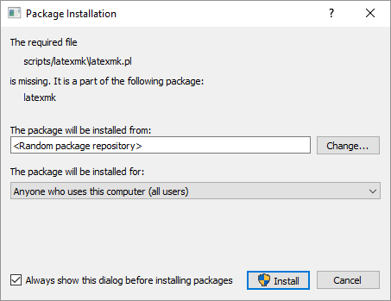  
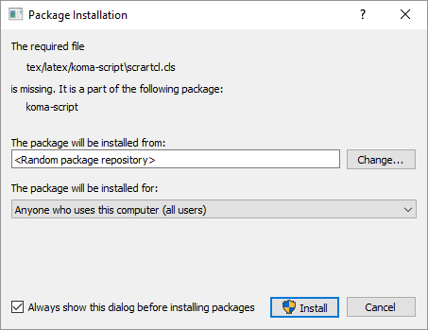

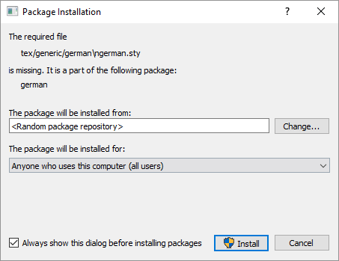  
und so weiter und so fort…